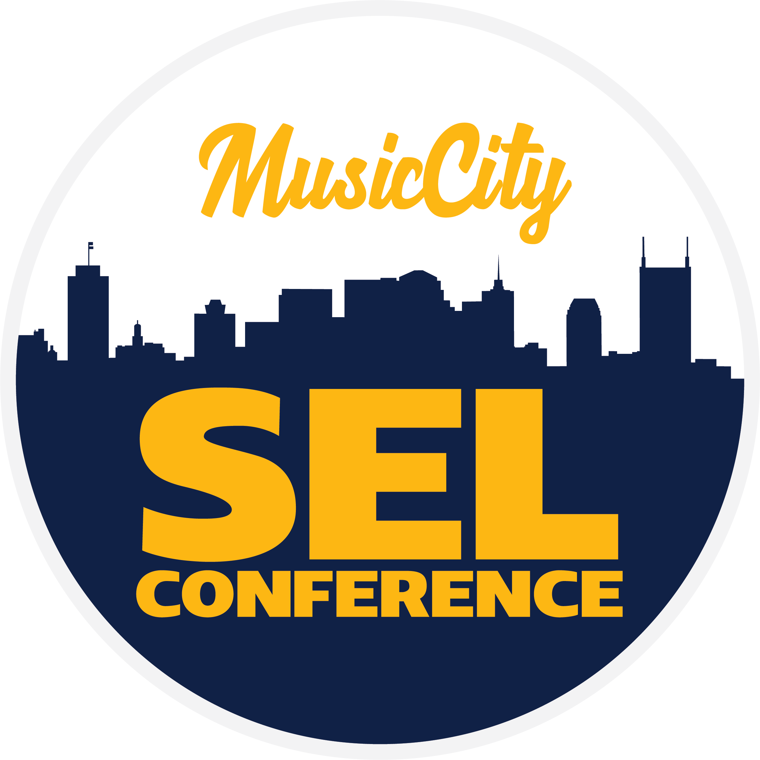
Music City SEL Youth Summit 2019 Participant Agreement
PLEASE RETURN THIS PAGE

Participant’s Name
School & Grade
Participant Email
Guardian’s Name
Guardian’s Cell

My signature below indicates that I understand, and have discussed with my child, acceptance and compliance with the following conditions and expectations required for all youth participants attending the Music City SEL Youth Summit:

- I hereby grant permission for my youth to participate in the Music City SEL Youth Summit on June 27, and 28, 2019 at Cane Ridge High School and authorize adult leader of Nashville STARS, Metro Nashville Public Schools, and/or Alignment Nashville to transport, monitor, and take appropriate, responsible action to ensure the safety and well-being of my youth.

- It is understood and agreed that all participants will abide by the General Rules of Conduct below. Violation of this agreement is unacceptable and participants may be sent home at parent expense.

GENERAL RULES OF CONDUCT
Participants agree to abide by the following rules:
- Participants are asked to be respectful of all other participants and staff;
- Participants are asked to fully participate in programming, including arriving on time;
- Youth participants are prohibited from using or possessing any drugs or alcohol;
- Participants agree not to engage in any illegal or inappropriate activity whatsoever;
- Youth participants may not leave the site of the specified meetings and/or events;
- Participants will help ensure the safety of all participants by immediately alerting leaders to any health or safety issues or any activities that violate the general rules or otherwise compromise the safety or well-being of other participants.

Participant(s) and legal guardian(s) signatures constitute understanding and agreement of the above rules. By signing below, the parent(s)/legal guardian(s) herby agree to indemnify and hold harmless Alignment Nashville, Nashville STARS, and Metro Nashville Public Schools and its leaders against and from any and all claims and damages, suits, and proceedings, medical expense or expense or any type, all of part thereof which arise out of or relate to any activities of the participant or the sponsors. In the event of an emergency, I/we hereby authorize a representation to contact me/us and, in the event that they cannot reach me/us, to engage a licensed doctor to render medical services which may, in the sole discretion of the doctor, be necessary. I/we further authorize said representative to take my/our child to the hospital if necessary and agree that I/we will pay all medical bills. I grant authorization for the sponsors to use my child’s name and image in media.

______________________________ ______________________________ _____________
Participant Name Signature Date

______________________________ ______________________________ _____________
Parent/Guardian Name Signature Date
IF YOU ARE PARTICIPATING AS PART OF A GROUP, RETURN THIS PAGE ONLY TO YOUR STARS COUNSELOR.
IF PARTICIPATING INDEPENDENTLY, SCAN & EMAIL TO JUSTIN@ALIGNMENTNASHVILLE.ORG.
RETAIN THE SECOND PAGE FOR YOUR RECORDS.

Music City SEL Youth Summit 2019 Important Information
PLEASE KEEP THIS PAGE

THANK YOU for allowing your child to attend the Music City SEL Youth Summit 2019. Please retain the following important information regarding the event.

What is the Music City SEL Youth Summit?
The Music City SEL Youth Summit is a special opportunity for middle and high school students to develop a deep understanding of social-emotional learning – the process through which children and adults acquire and effectively apply the knowledge, attitudes, and skills necessary to understand and manage emotions, set and achieve positive goals, feel and show empathy for others, establish and maintain positive relationships, and make responsible decisions.

Participants will learn about the role they play as youth leaders working to enhance the climate of their schools and develop action plans in collaboration of adult leaders. The Youth Summit is part of the Music City SEL Conference – a national gathering of educators and youth-serving professionals focused on social emotional learning.

Thursday, June 27 & Friday, June 28
High School Youth ONLY
8:30am | SYouth ummit Begins at Cane Ridge High School
12:00pm | Lunch
3:00pm | Youth Summit Concludes

Who should attend?
The Music City SEL Youth Summit is designed for student leaders in or around the greater Nashville area who are active in their schools’ STARS programs, SADD clubs, school climate teams, or related student leadership clubs and programs. To get the most out of the summit,
youth are encouraged, but not required, to attend as part of a team from their school.

What is the cost?
The Music City SEL Youth Summit is sponsored by Nashville STARS, Metro Nashville Public Schools, and Alignment Nashville and offered at no cost to participants. Lunch and snacks will be provided on both days.

If you have any addition questions or concerns, please contact:
Justin Sweatman-Weaver  Events & Communications Manager  Alignment Nashville  justin@alignmentnashville.org | Melissa Gordon  Restorative Justice Specialist  Metro Nashville Public Schools  Melissa.Gordon@mnps.org

